CSA1708-ARTIFICIAL INTELLIGENCE
LAB EXPERIMENTS

Program 4: write the python program for cript arithmetric problem
Aim:
To write a Python program to solve the cryptarithmetic problem SEND + MORE = MONEY by assigning unique digits to each letter.
Algorithm:
- Start the program.
- Import the permutations function from the itertools module.
- Generate all possible assignments of eight distinct digits (0–9) to the letters S, E, N, D, M, O, R, and Y.
- Check that the leading digits S and M are not zero.
- Convert SEND, MORE, and MONEY into their corresponding numerical values.
- Check whether the equation SEND + MORE = MONEY is satisfied.
- If the equation is satisfied, display the values of SEND, MORE, and MONEY.
- Stop the program.
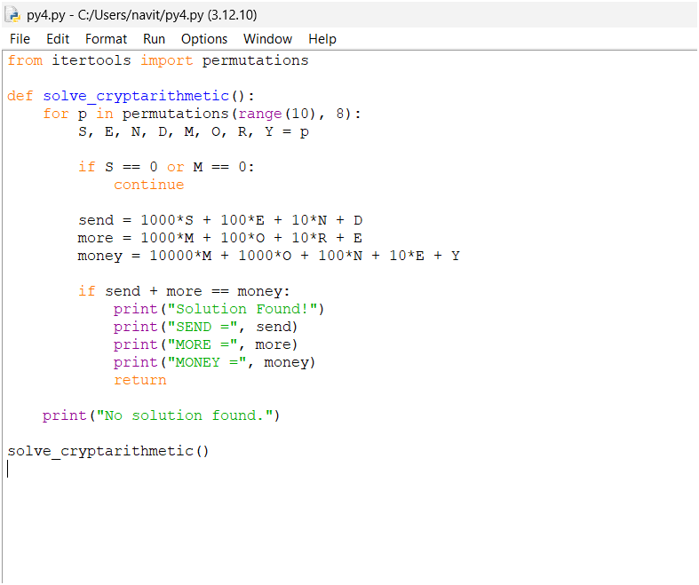
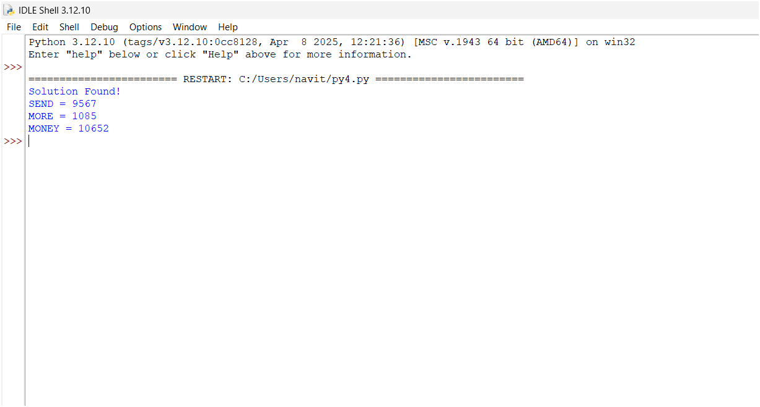
Result:
Thus, the Python program successfully solves the cryptarithmetic problem and verifies that 9567 + 1085 = 10652.

